May 4th, 2026
- Legal bench: Accuracy (evaluation criteria)
- Legal bench: RLM (currently we have RULER)
- Legal bench: True baseline (just API calls)

Legal Contract Review
[2103.06268] CUAD: An Expert-Annotated NLP Dataset for Legal Contract Review
Dataset: Commercial legal contracts that have been manually labeled to identify 41 categories of important clauses that lawyers look for when reviewing contracts in connection with corporate transactions.
Example queries:
- Highlight the parts (if any) of this contract related to \"Parties\" that should be reviewed by a lawyer.
- Highlight the parts (if any) of this contract related to \"Agreement Date\" that should be reviewed by a lawyer.
- Highlight the parts (if any) of this contract related to \"Effective Date\" that should be reviewed by a lawyer.
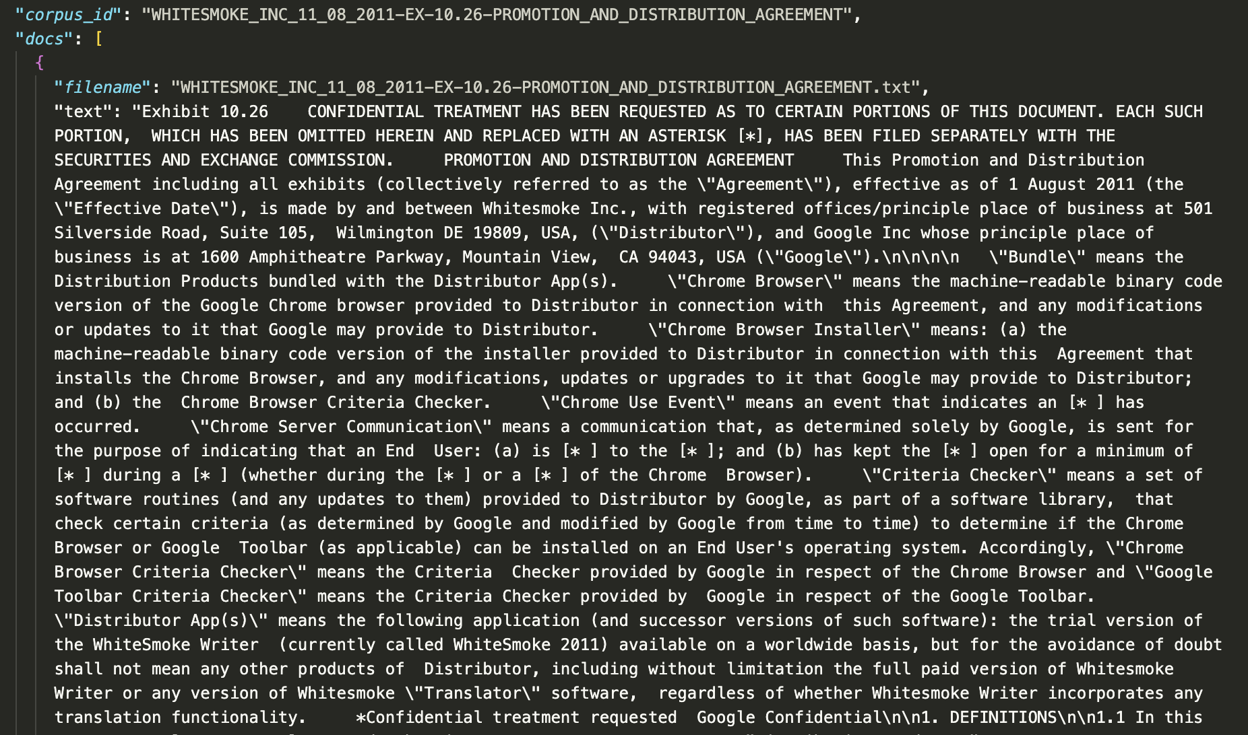

- Baseline (no caching)
"elapsed_seconds": 4848.257,
"cases_selected": 60,
"mode": "baseline",
"total_api_calls": 360,
"total_input_tokens": 498161,
"total_output_tokens": 113249,
"total_tokens": 611410,
"total_estimated_cost_usd": 1.962066,
"answer_accuracy": 0.583333,

- Cache cold start
"elapsed_seconds": 3402.981,
"cases_selected": 60,
"mode": "cache",
"total_api_calls": 285,
"total_input_tokens": 330802,
"total_output_tokens": 75845,
"total_tokens": 406647,
"total_estimated_cost_usd": 1.278803,
"answer_accuracy": 0.666667,

- Warm start (use cache from previous run)
"elapsed_seconds": 659.463,
"cases_selected": 60,
"mode": "cache",
"total_api_calls": 30,
"total_input_tokens": 7588,
"total_output_tokens": 420,
"total_tokens": 8008,
"total_estimated_cost_usd": 0.009688,
"answer_accuracy": 0.666667,

RULER
RLM:
"samples_selected": 3,
"total_input_tokens": 690385,
"total_output_tokens": 12021,
"total_tokens": 702406,
"total_estimated_cost_usd": 0.75049,
"elapsed_seconds": 733.477,
"overall_accuracy": 1.0,

Two-Stage Semantic Cache:
- Baseline (no caching)
"elapsed_seconds": 8357.192,
"samples_selected": 102,
"mode": "baseline",
"total_api_calls": 306,
"total_input_tokens": 480143,
"total_output_tokens": 34397,
"total_tokens": 514540,
"total_estimated_cost_usd": 1.219166,
"overall_accuracy": 0.8112745098039216,

- Cache cold start
"elapsed_seconds": 8017.457,
"samples_selected": 102,
"mode": "cache",
"total_api_calls": 306,
"total_input_tokens": 479879,
"total_output_tokens": 33636,
"total_tokens": 513515,
"total_estimated_cost_usd": 1.212457,
"cache_state_existed_before_reset": false,
"cache_state_existed_before_run": false,
"cache_reset_requested": true,
"cache_load_attempts": 102,
"cache_load_successes": 101,
"cache_entries_before_run": 0,
"cache_entries_after_run": 102,
"cache_hits": 0,
"cache_hit_rate": 0.0
"overall_accuracy": 0.8112745098039216,

- Warm start (use cache from previous run)
"elapsed_seconds": 3764.086,
"samples_selected": 102,
"mode": "cache",
"total_api_calls": 0,
"total_input_tokens": 0,
"total_output_tokens": 0,
"total_tokens": 0,
"total_estimated_cost_usd": 0.0,
"cache_state_existed_before_reset": true,
"cache_state_existed_before_run": true,
"cache_reset_requested": false,
"cache_load_attempts": 102,
"cache_load_successes": 102,
"cache_entries_before_run": 102,
"cache_entries_after_run": 102,
"cache_hits": 102,
"cache_hit_rate": 1.0
"overall_accuracy": 0.8112745098039216,

